Laboratory Work 1

Part 1

Relation A
Superkeys examples: {EmpID}, {SSN}, {Email}, {EmpID, Phone}, {SSN, Email}, {Email, Department, Salary}.
Candidate keys: EmpID, SSN, Email.
Primary key chosen: EmpID (stable, simple, not personal/confidential).
Phone number is not guaranteed unique, so it cannot be a key.

Relation B
Primary key: (StudentID, CourseCode, Section, Semester, Year).
Explanation: needed to uniquely identify a registration record.
Additional candidate key if SectionInstanceID exists: (StudentID, SectionInstanceID).

Task 1.2
Student.AdvisorID → Professor.ProfID
Professor.Department → Department.DeptCode
Course.DepartmentCode → Department.DeptCode
Department.ChairID → Professor.ProfID
Enrollment.StudentID → Student.StudentID Enrollment.CourseID → Course.CourseID

Part 2

Task 2.1:

1. Entities
- Patient (Strong)
- Doctor (Strong)
- Department (Strong)
- Appointment (Weak — depends on Patient and Doctor for uniqueness)
- Prescription (Weak — depends on Patient + Doctor + Medication)
- Hospital Room (Strong, but identified by composite key with Department)

2. Attributes

patient
- patient_id (PK, simple)
- name (composite: first_name, last_name, middle_name)
- birthdate (simple)
- address (composite: street, city, state, zip)
- phone_numbers (multi-valued)
- insurance_info (simple)

Doctor
- doctor_id (PK)
- name (composite)
- specialization (multi-valued)
- phone_numbers (multi-valued)
- office_location (simple)

Department
- dept_code (PK)
- dept_name (simple)
- location (simple)

Appointment
- appointment_id (PK)
- date_time (simple)
- purpose (simple)
- notes (simple)
- patient_id (FK)
- doctor_id (FK)

Prescription
- prescription_id (PK)
- dosage (simple)
- instructions (simple)
- patient_id (FK)
- doctor_id (FK)

Hospital Room
- room_number (partial key)
- dept_code (FK → Department, together with room_number forms composite PK)

3. Relationships
- Patient — Appointment — Doctor
  - M:N (since one patient can have many doctors, and one doctor sees many patients).
  - Resolved with Appointment entity (weak).
- Doctor — Department
  - M:1 (a doctor belongs to exactly one department; department has many doctors).
- Patient — Prescription — Doctor
  - M:N resolved with Prescription entity.
- Department — Hospital Room
  - 1:N (one department has many rooms; each room belongs to one department).

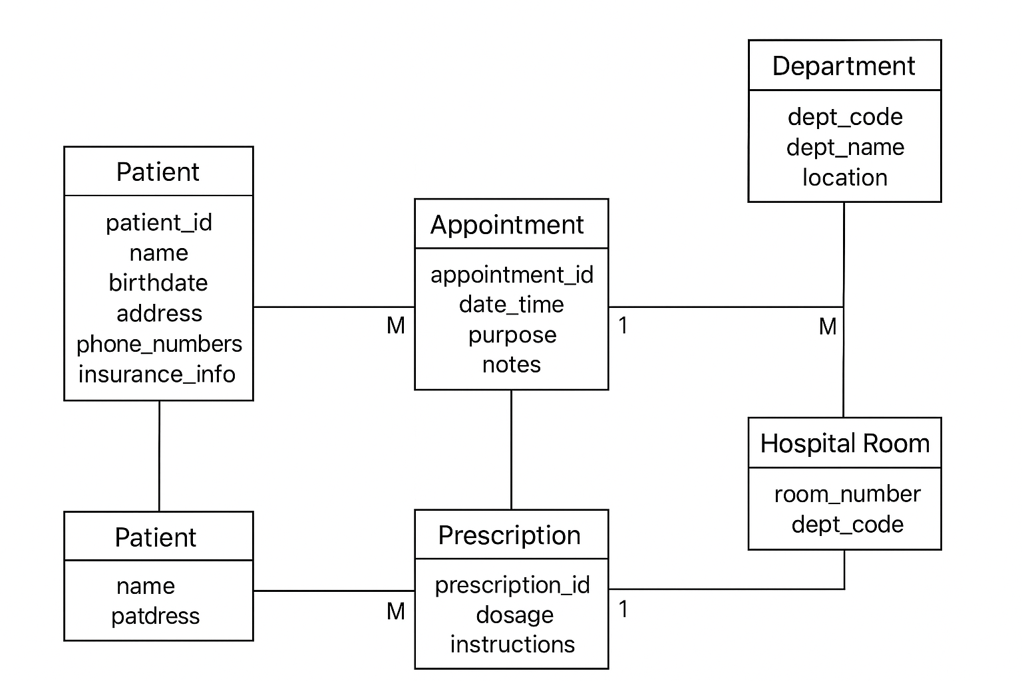

Task 2.2

1. Entities
- Customer (Strong)
- Order (Strong)
- Order Item (Weak — depends on Order and Product)
- Product (Strong)
- Category (Strong)
- Vendor (Strong)
- Review (Weak — depends on Customer and Product)
- Inventory (Strong)
- Address (Strong, but used in M:N with Customer)

2. Attributes

Customer
- customer_id (PK)
- name (composite)
- email (simple)
- phone (simple)
- billing_address (composite, or linked to Address entity)

Order
- order_id (PK)
- order_date (simple)
- total_amount (derived from Order Items)
- customer_id (FK)

Order Item (Weak)
- order_id (FK, part of PK)
- product_id (FK, part of PK)
- quantity (simple)
- price_at_order (simple)

Product
- product_id (PK)
- name (simple)
- description (simple)
- price (simple)
- category_id (FK)
- vendor_id (FK)

Category
- category_id (PK)
- category_name (simple)

Vendor
- vendor_id (PK)
- vendor_name (simple)
- contact_info (simple)

Review (Weak)
- review_id (PK)
- rating (simple)
- comment (simple)
- product_id (FK)
- customer_id (FK)

Inventory
- product_id (PK, FK)
- stock_level (simple)

Address
- address_id (PK)
- street, city, state, zip (composite)

3. Relationships
- Customer — Order
  - 1:N (one customer places many orders).
- Order — Order Item — Product
  - M:N resolved with Order Item (weak).
- Product — Category
  - M:1 (product belongs to one category; category has many products).
- Product — Vendor
  - M:1 (product has one vendor; vendor supplies many products).
- Product — Review — Customer
  - M:N resolved with Review (weak).
- Product — Inventory
  - 1:1 (each product has one inventory record).
- Customer — Address
  - M:N (customers can have multiple addresses; addresses can belong to multiple customers in different contexts like billing/shipping).

4. Weak Entities & M:N with attributes
- Weak entity:
  - Order Item → depends on Order + Product.
  - Review → depends on Customer + Product.
- M:N needing attributes:
  - Order–Product → resolved with Order Item (stores quantity, price).
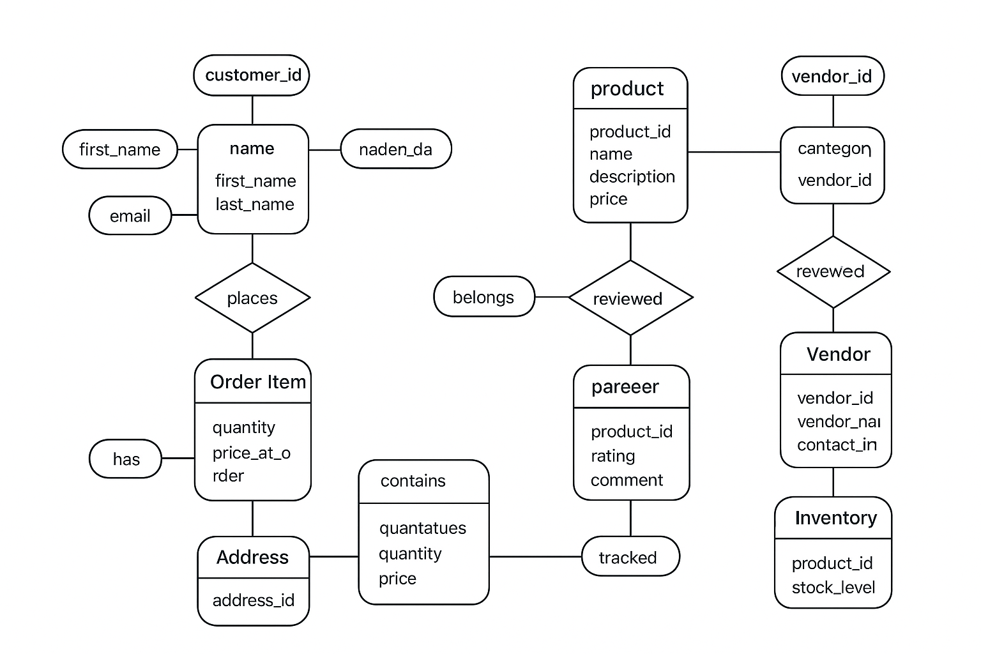

Part 4:

Task 4.1

FDs:
- StudentID → StudentName, StudentMajor
- ProjectID → ProjectTitle, ProjectType
- SupervisorID → SupervisorName, SupervisorDept
- (StudentID, ProjectID) → Role, HoursWorked, StartDate, EndDate
Problems: Redundancy (students, projects, supervisors). Update, insert, delete anomalies.
1NF: Attributes atomic.
2NF: PK = (StudentID, ProjectID). Decompose into:
- Student(StudentID, Name, Major)
- Project(ProjectID, Title, Type, SupervisorID)
- Supervisor(SupervisorID, Name, Dept)
- StudentProject(StudentID, ProjectID, Role, HoursWorked, StartDate, EndDate)
3NF: Transitive dependencies removed.

Task 4.2
FDs:
- StudentID → Major
- CourseID → CourseName
- InstructorID → InstructorName
- (Room, TimeSlot) → Building
- (CourseID, TimeSlot, Room) → InstructorID
- (StudentID, CourseID, TimeSlot, Room) → enrollment info
PK: (StudentID, CourseID, TimeSlot, Room)
BCNF Check: Not in BCNF (violations: StudentID → Major, etc.).
BCNF Decomposition:
- Student(StudentID, Major)
- Course(CourseID, Name)
- Instructor(InstructorID, Name)
- RoomSchedule(Room, TimeSlot, Building, InstructorID, CourseID)
- Enrollment(StudentID, CourseID, TimeSlot, Room)
Result: No information loss, but more joins required.

Part 5:
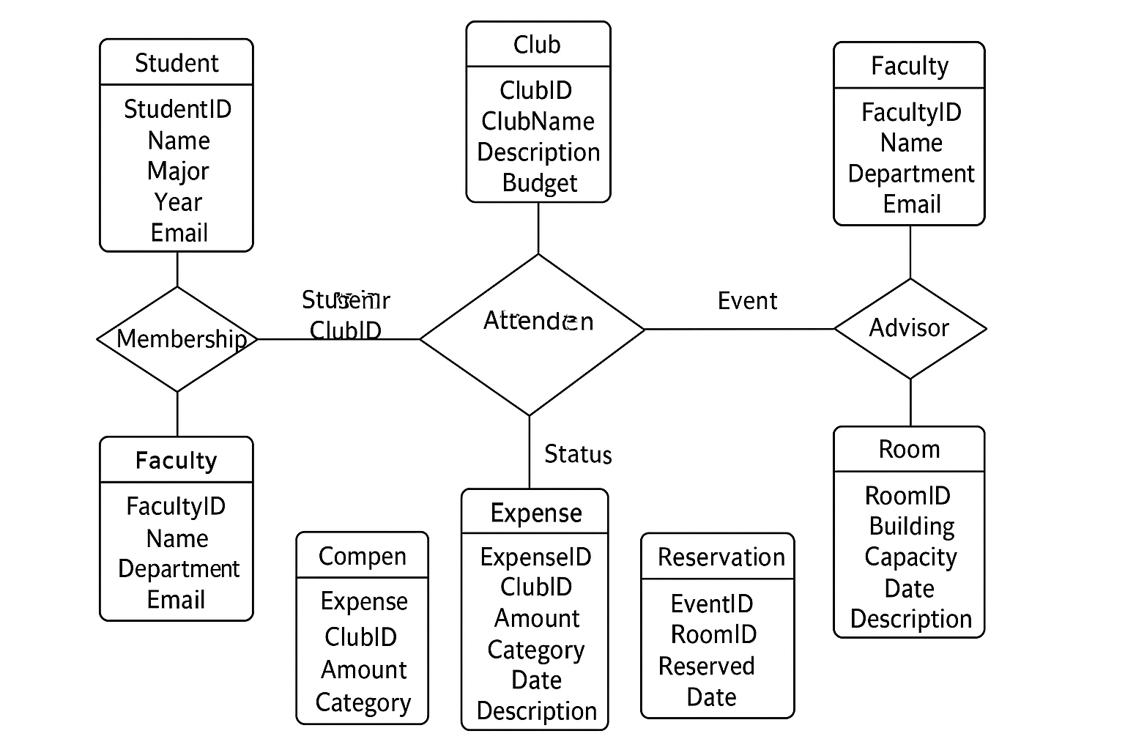

Task 5.1

2. Relational Schema (normalized, 3NF)
- Student(StudentID, Name, Major, Year, Email)
- Club(ClubID, ClubName, Description, Budget)
- Membership(StudentID, ClubID, JoinDate, Role)
- Event(EventID, ClubID, EventName, Date, Time, Location)
- Attendance(StudentID, EventID, Status)
- Faculty(FacultyID, Name, Department, Email)
- Advisor(FacultyID, ClubID)
- Room(RoomID, Building, Capacity)
- Reservation(EventID, RoomID, ReservedDate)
- Expense(ExpenseID, ClubID, Amount, Category, Date, Description)

3. Design Decision (example)
For officer roles (president, treasurer, etc.), I had two choices:
- Create a separate Officer table.
- Store officer role as an attribute in Membership.
I chose option 2, because it avoids duplication and keeps membership + role in one place.

4. Example Queries (in English)
- “Find all students who are officers in the Computer Science Club.”
- “List all events scheduled for next week with their reserved rooms.”
- “Show the total expenses for each club this semester.”

